Experiment 10: Perform Moving (Translation) of an Image from One Place to Another
Aim
To perform image translation (moving an image from one position to another) using Python and OpenCV.
Software Requirements
- Python 3.x
- OpenCV (cv2)
- NumPy
- Visual Studio Code / PyCharm / Jupyter Notebook
Procedure
- Install the required libraries using:
- Import the required libraries (cv2 and numpy).
- Read the input image using cv2.imread().
- Check whether the image is loaded successfully.
- Create a translation matrix to move the image horizontally and vertically.
- Apply the translation using cv2.warpAffine().
- Display both the original and translated images.
- Press any key to close all image windows.
Python Code
import cv2
import numpy as np
# Read the input image
image = cv2.imread("sample.jpg")
# Check if image is loaded
if image is None:
print("Error: Image not found!")
exit()
# Get image dimensions
rows, cols = image.shape[:2]
# Translation values
tx = 100 # Move 100 pixels to the right
ty = 50 # Move 50 pixels downward
# Create the translation matrix
M = np.float32([[1, 0, tx],
[0, 1, ty]])
# Apply translation
translated = cv2.warpAffine(image, M, (cols, rows)
# Display images
cv2.imshow("Original Image", image)
cv2.imshow("Translated Image", translated)
# Wait until a key is pressed
cv2.waitKey(0)
# Close all windows
cv2.destroyAllWindows()
Output
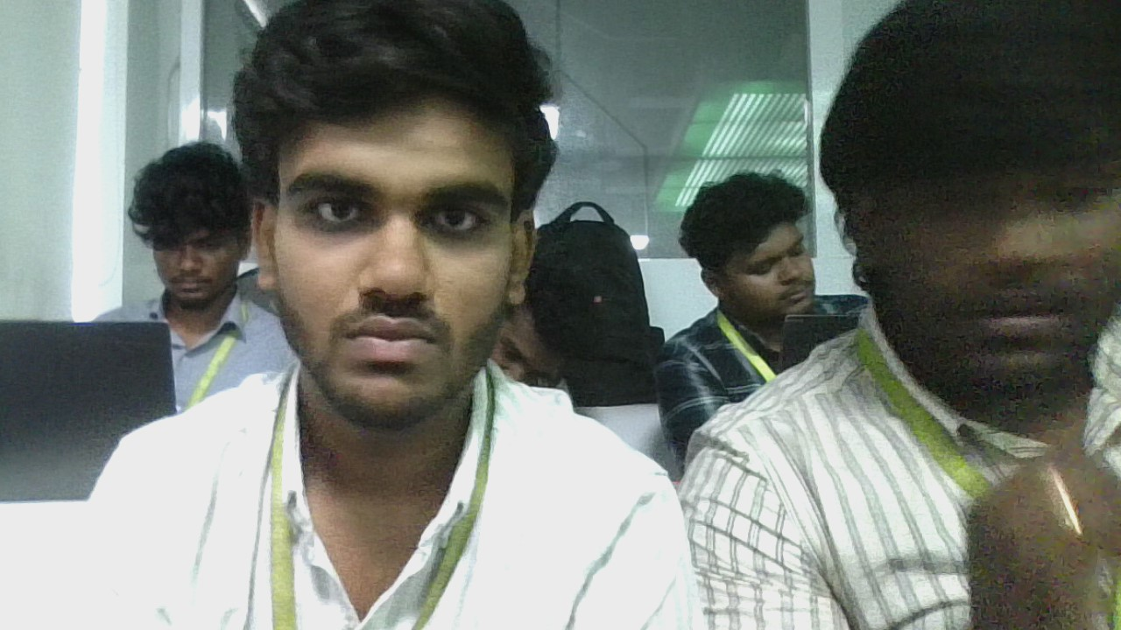


Result
The input image was successfully translated (moved) from its original position to a new position using the translation transformation in Python with OpenCV. The translated image was displayed successfully.

